**PHY1002 Physics Laboratory**

**Short Report**

|  |  |  |  |
| --- | --- | --- | --- |
| Name: | CHEN Haopeng | Student ID: | 120090645 |
| Group: | 8 | Date of Experiment: | Nov. 9th, 2021 |

**Experiment 3. Conservation of Momentum**

1. Calculate the initial and the final momentum of the system for the collisions below:
   1. Completely Inelastic Collision for both equal mass carts and unequal mass carts

Equal Mass Carts Case:

$$p_{initial}=0.26529kg×0.313m/s+0.27429kg×0m/s$$

$$=(8.304±0.001)×{10}^{-2}kg∙m/s$$

$$p_{final}=0.26529kg×0.143m/s+0.27429kg×0.143m/s$$

$$=(7.716±0.001)×{10}^{-2}kg∙m/s$$

Unequal Mass Carts Case:

* 1. Elastic Collisions for both equal mass carts and unequal mass carts

Equal Mass Carts Case:

$$p_{initial}=0.26529kg×0.522m/s+0.27429kg×0m/s$$

$$=0.13848±0.00002kg∙m/s$$

$$p_{final}=0.26529kg×(-0.0018m/s)+0.27429kg×0.485m/s$$

$$=0.13255±0.00001kg∙m/s$$

Unequal Mass Carts Case:

$$p_{initial}=0.26529kg×0.446m/s+0.52747kg×0m/s$$

$$=0.11832±0.00001kg∙m/s$$

$$p_{final}=0.26529kg×(-0.141m/s)+0.52747kg×0.280m/s$$

$$=0.11029±0.00001kg∙m/s$$

1. Plot the Graphs of total momentum ($P_{total}$) vs. time and total kinetic energy ($KE_{total}$) vs. time for all the cases mentioned in Question 1. (Two Graphs required. (a) $P_{total}$ vs. time; and (b) $KE_{total}$ vs. time for all the collisions)

Inelastic with Equal Mass:

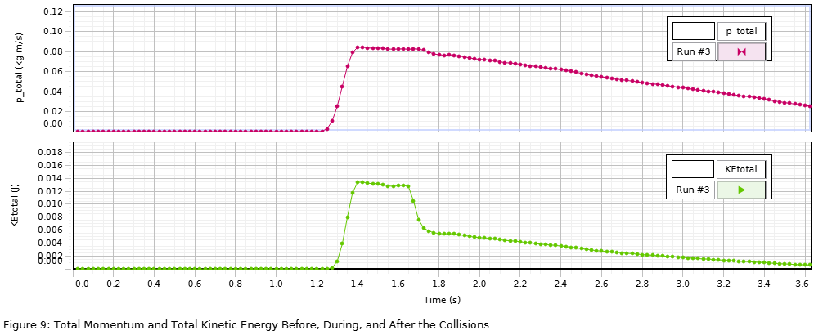

Inelastic with Unequal Mass:

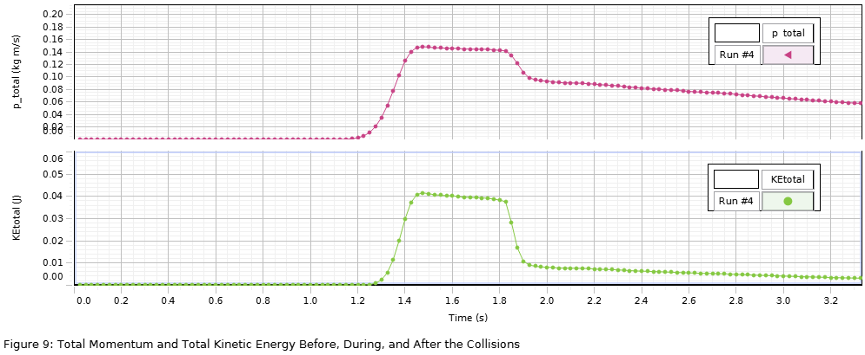

Elastic with Equal Mass:

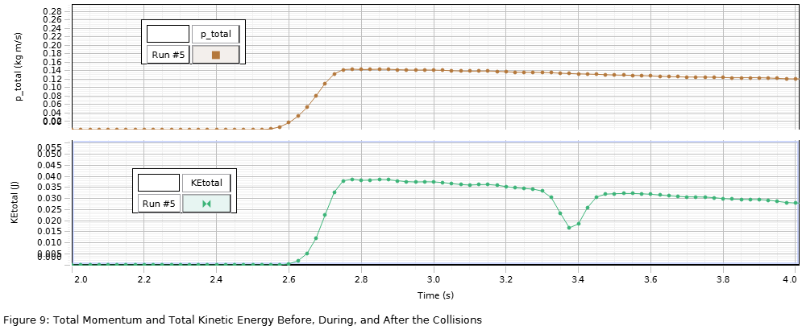

Elastic with Unequal Mass:

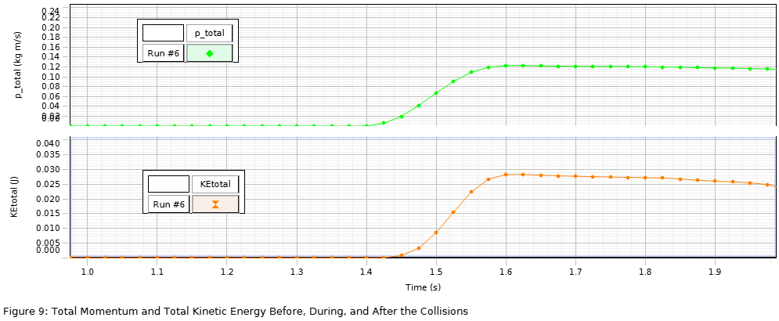

3. Explain the Graphs in Question 2. What happens before, during, and after the collisions in terms of momentum, velocity, and kinetic energy?

For inelastic collisions, the momentum of the system preserves but the kinetic energy of the system decreases after collisions. And the red one and the blue one will have the same slower velocity.

For elastic collisions, the momentum and the kinetic energy of the system preserves. If the red cart weights equal to the blue cart, they will exchange the velocity. If the blue cart is heavier than the red one, the red one will go back forward, and the blue go ahead.

Appendix:

Attach the table in Procedure explosions, Inelastic collisions, elastic collisions. (you should write a clear and detailed caption for each table.)

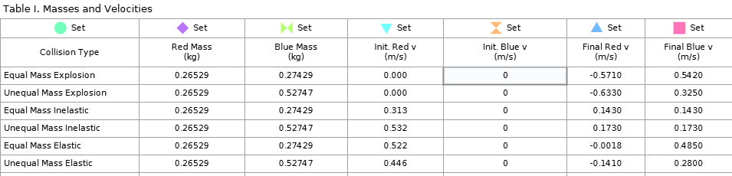

For Explosion, we first conducted the equal mass one. Set the plunger on red cart to position #2 and put two carts contacted with each other at the center. Start recording and tap the trigger to launch the plunger. And stop recording before either of them hits the edge. Then, we put a $250g$ mass on the blue cart and repeat previous steps.

For inelastic collision, we first place the blue one at the center and the red one is on the left of blue with certain distance, with the Velcro® bumpers facing with each other. Then, we start recording and give a short push to the red cart. Stop recording after collision and before either of them hits the rim. And we put a $250g$ mass on the blue to repeat the previous steps.

For elastic collision, we place them like the inelastic collision but with the magnetic sides facing with each other. Then, we record, push, stop recording. And, add a $250g$ mass, do it again.

____________________________________________________________________

--- End of Laboratory Report ---

**Notes:**

* **Submit soft copies online.**
* **No further modification allowed after deadline.**
* **Please don’t exceed 2 pages (exclude appendix), with normal margin and 1.0 line space.**
* **No figure is required if not specified.**